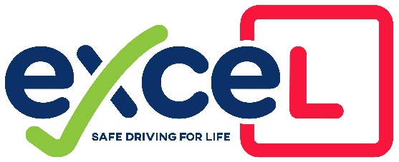

COVID-19 Amended Terms and Conditions

* The Instructor or Pupil can cancel the lesson at any time if they, a member of their family or friend they have been in contact with shows symptoms of the virus.
* If the Instructor feels the Pupil looks unwell or has a temperature at the start of the Lesson, the Lesson will be terminated and charged.
* If the Instructor is asked to Isolate due to Track and Trace, He is not liable to compensate for any test booking within that isolation period although every effort will be made to find the pupil another instructor to take them to Test.
* The Instructor or Pupil have the right to cease lessons at anytime if they feel that it’s becoming “unsafe”.
* The Lesson will be cancelled if the Pupil has forgotten their face mask and can’t find it or a replacement.
* All Lessons will now start from “Home” but can finish at another destination if required.