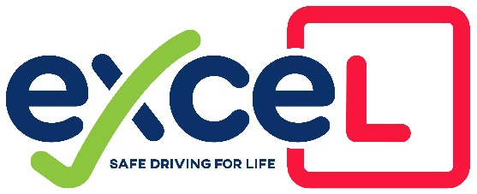
COVID-19 Risk Mitigation
- Instructor to ring and check on health of Pupil, Family and any friends the day before lesson
- Lessons to start from home address only but my finish at another address if arranged prior to lesson with Instructor
- Preferred Lesson Payment by Bank Transfer or correct money sealed in envelope with pupil’s name and date of lesson written on the front.
- There is a £1 per hour additional charge to Lessons to help contribute to the cost of PPE
- Instructor to text on day of lesson to check no change in health
- Before the Lesson the Instructor will wipe down controls and initial Car Cleaning Checklist
- Pupil to wash hands before exiting house
- Pupil advised to wear long sleeved top and Leggings/Joggers/Jeans
- The Pupil must bring their own mask, if they can’t find it, then they will have opportunity to find it but it will be in the lesson time. Failure to have a mask will result in the lesson being cancelled and charged for.
- Any bags to be left at home and phone to be kept in pocket at all times
- The Instructor to bring packed lunch to prevent having to stop in-between lessons to buy drinks
- The Instructor to ensure there’s enough fuel to last for the day to prevent risk while refuelling
- The Instructor will wait by the car at the start of the lesson and not approach the front door
- Before getting in the Car, the instructor will assess the health of the pupil and take both their temperatures using infra-red Thermometers.
- NEW PUPILS, please enter your driving licence number on the app and show licence to instructor on 1st lesson, Instructor should not touch it
- Instructor to ensure seat and steering wheel covers used before pupil gets into drivers seat
- Pupil not to touch any training aids
- Any briefings/breaks to be taken outside the car where possible and if not both pupil and Instructor to face forward
- Front nearside and rear offside windows to be open to allow flow of air through car
- Instructor to ensure air recirculation and air-con to be switched off
- During the day the Instructor to limit returning home for refreshment breaks. If necessary to limit contact with their household and keep touching anything to a minimum
- Instructor to remove clothes when they return home at the end of the day and shower to remove any contamination
- Fresh PPE will be stored in the boot and Instructors used PPE will be bagged up and sealed on the back seat in a larger bag and disposed of at the end of the day.
- Pupils PPE will be put in a sealed bag for the pupil to dispose of to prevent cross contamination.

Signed

……………………………..

This list will be assessed every week and amended where necessary in line with Government/DVSA/DIA guidelines

